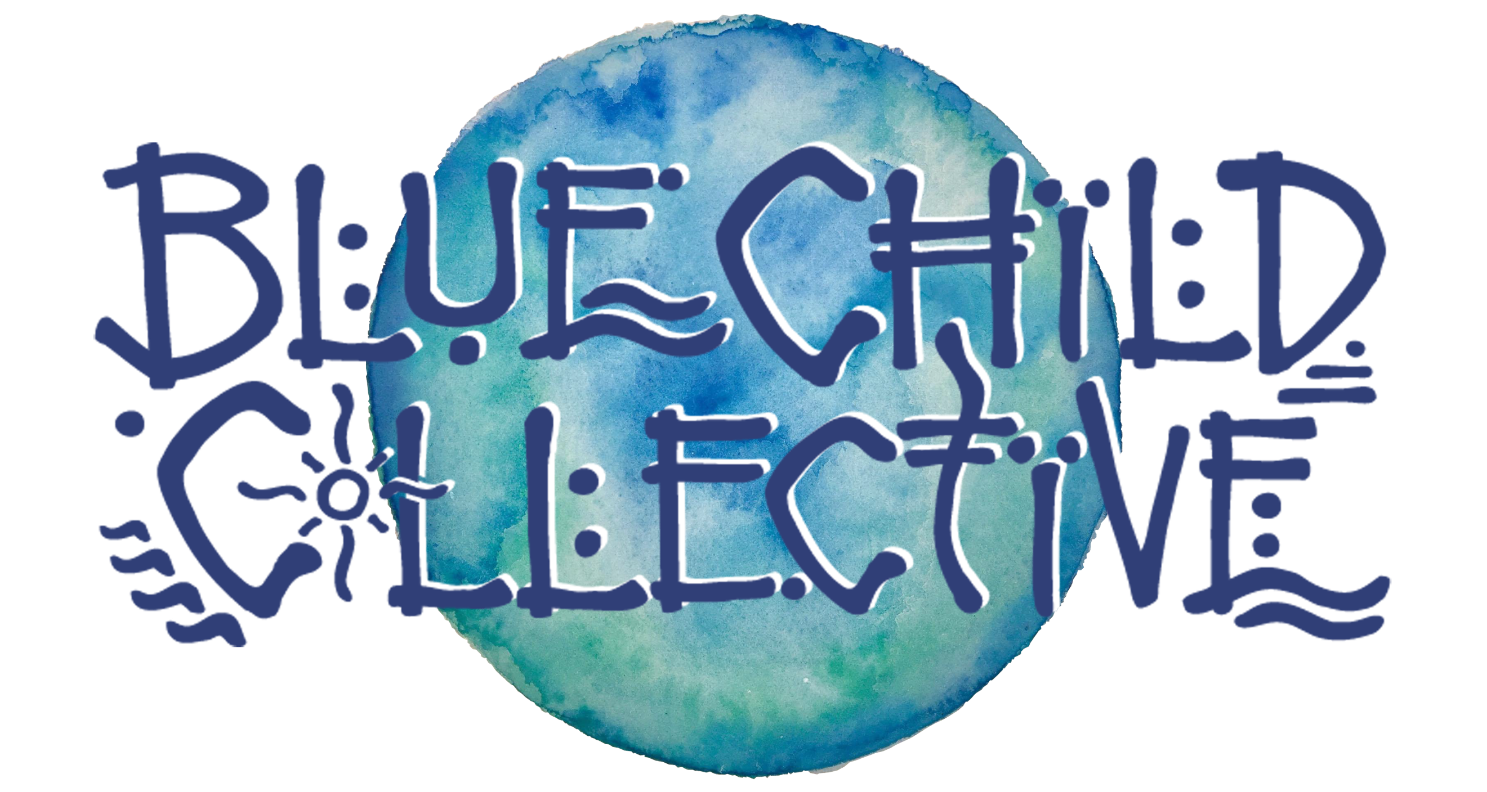

___________________________________________

- Creativity - Collaboration - Connection -

_____________________

A Fluid Groove 5-Piece born from the West Australian coastline, Blue Child Collective's easy-flowing, conscious song craft "evokes the gentle rhythms and roaring freedom of Australia’s seaside" (Happy Mag).

Fronted by Dan White, director of The West Australian Guitar Festival, keen multi-instrumentalist and fingerstyle artisan, this is music with purpose. From his thought-provoking lyrics to the Collective’s engaging live performances, “Blue Child Collective is connecting people through music” (Scenstr), creating waves that have earned them a recent nomination for West Australian Music’s Best Regional Act and shows with The Cat Empire, Sticky Fingers, Xavier Rudd, San Cisco, Sola Rosa, The Jungle Giants and many more.

The Collective's third record, “Saturn Saw The Seaside”, captured in Corsica, France and released late 2016 saw them knock out over 250 shows across Europe, New Zealand, Australia and Singapore in 2 years of full on touring, bringing both full band dance offs and intimate duo performances to a rapidly growing global following.

With their 4th record, “Wake Up To The Sound”, featuring an all class line up just out in November and fresh off the back of a 16-date Australian Tour as a 5-piece in Jan-Feb, the Collective are set to bring the new album to New Zealand in March, with another documentary titled “The Art Of Sound” out later this year.

Plug in, connect and get involved: Blue Child Collective is fast becoming a major catalyst for positive change on a global scale as more and more people join the movement and contribute to the “Culture Of Connection”.

www.bluechildcollective.com
@bluechildcollective
#bccfamily #cultureofconnection

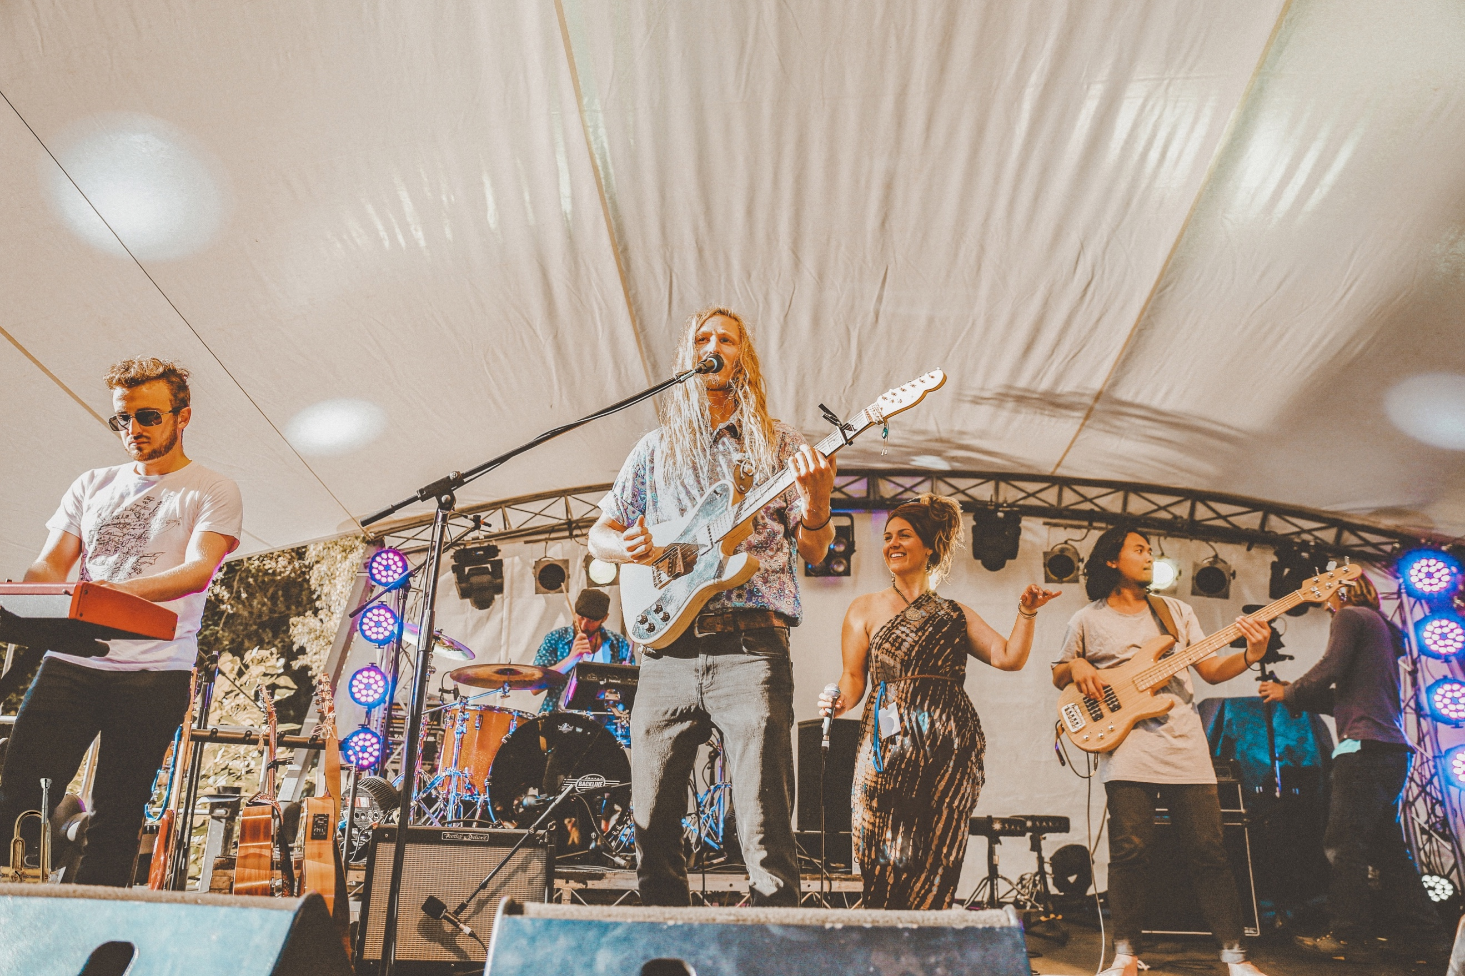
(@sarastormphotography)

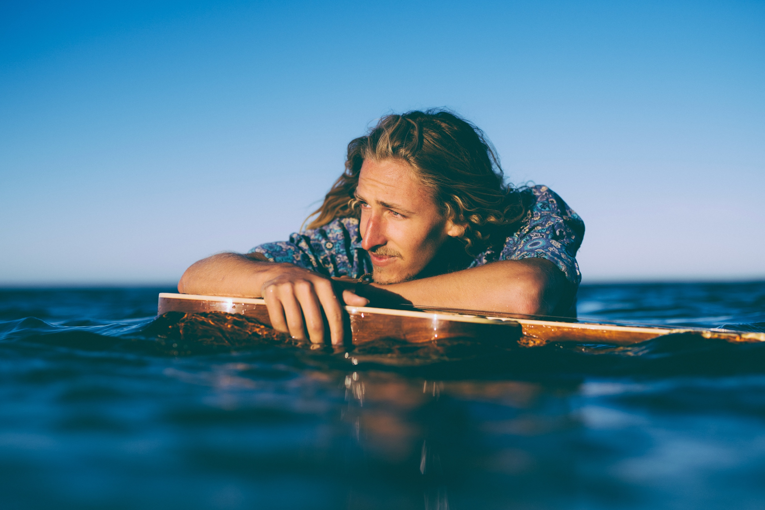
(@russellordphoto)

